S88-N Pinouts

DESKTOP STATION | PIN 5 | PIN 4 | PIN 3 | A0 | GND | +5 V
IC-Connector | DATA IN  RESET | PS / LOAD | CLOCK | DATA OUT | GND | +5V
ARDUINO | PIN 12 | PIN 3 | PIN 2 | PIN 13 | GND | +5 V

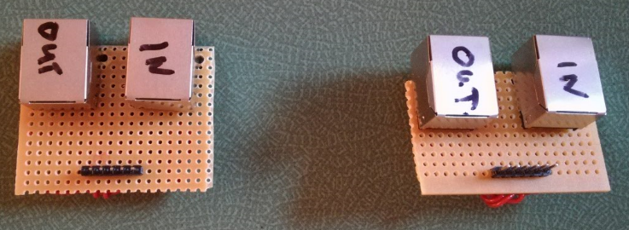
GND
OUT: nur bei DesktopStation(!!)
IC-Connector
...from OUT additional S88

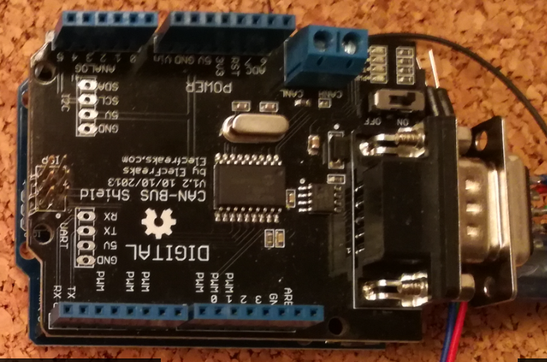

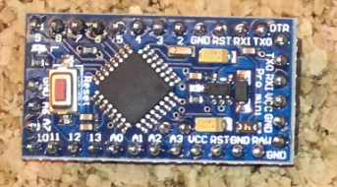

Usable PINs for S88-Feedback

A0, A1, A2, A3, A4, A5,
0, 1, 4, 5, 6, 7, 8, 9, 10, 11

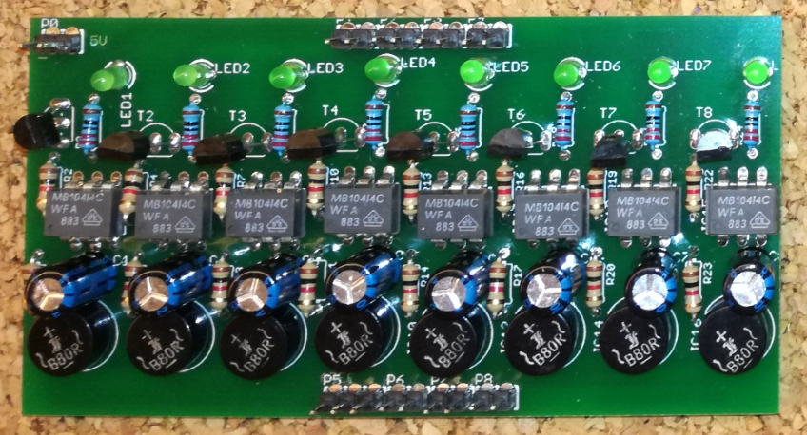

S88-RJ45-Bridge

